**Assignment 6.3**

**Problem statement1:** Find the number of GoogleKnowlege_Occupation people who were guests in the show, in a particular time period. Take the time period as 1/11/99 to 6/11/99 i.e., 6 months.

**Problem statement2:** Find the number of Google Knowledge occupation types in each group, who have been guests on the show.

**Driver:**

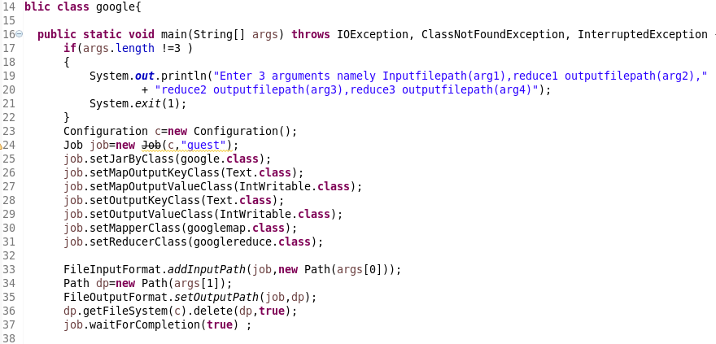

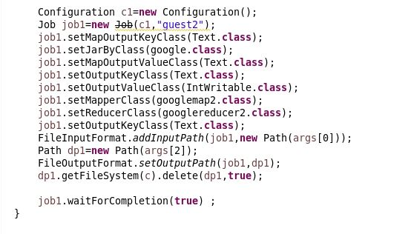

**MAPPPER CLASS (qn1):**

**LOGIC:** Splitting by comma and then filter them by date between the given dates BY USING LOCAL DATE and then sending the guest as key and value as 1 for each people

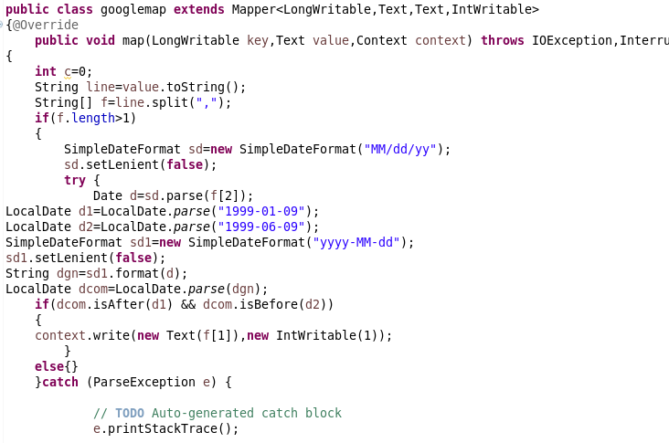

**REDUCER:**

Count the number of guests

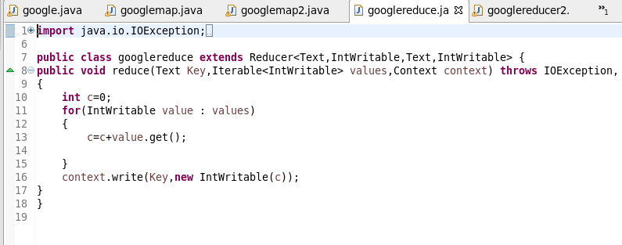

**MAPPER (For Problem statement 2):**

Splitting by comma and then sending Group and the Guests as key and value.

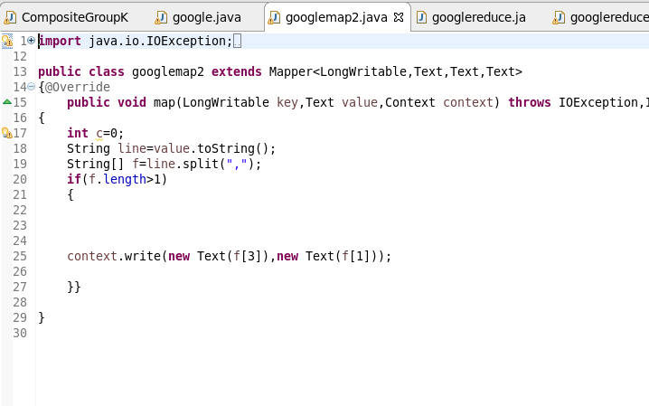

**REDUCER:**

USED hash set to remove Duplicate guests and then send it as value as we want unique number of guests in each group.

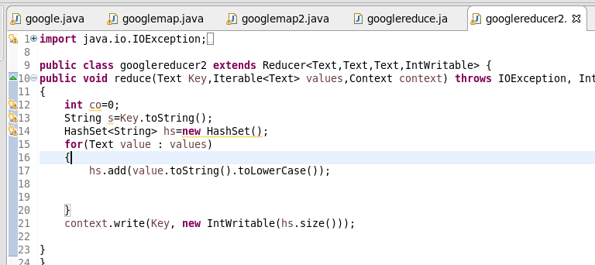

**RUNNING JAR:**

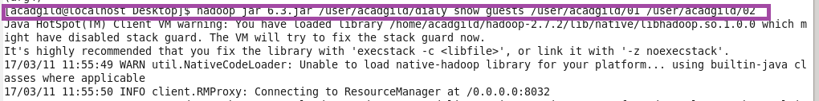

**OUTPUT 1:**

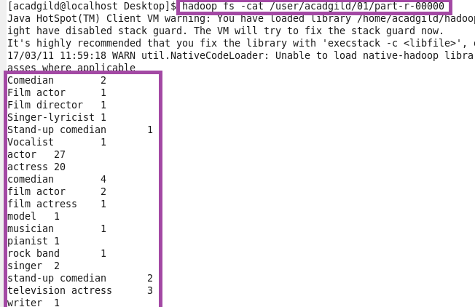

**OUTPUT 2:**

